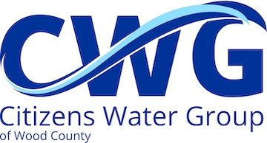

CWG Agenda
Citizens Water Group (of Wood County)
Mon., May 18th; 2:00 pm
In-Person (Riverblock Auditorium, Room # 206) & VIRTUAL mtg.
WebEx Connect information below

*** CHAIR’S NOTE *** Please disregard any e-mail indicating that CWG meeting has been
postponed or cancelled.

- Call to Order / Possible Introductions
- Public Comment (Either now or at the time the agenda item is discussed)
- Approve minutes of April 20th mtg.
- Correspondence / Updates / Handouts / Reports on meetings attended
- Detailed follow-up to BENNET GOLDSTEIN’S ATTENDANCE @ April 20th CWG meeting (Article publication, date, media, access, etc.)
- Focused 2026 Recommended CWG Actions:
MAY–PROMOTE CWG MISSION
June–Increasing Membership
July–Grants / Actions Wish List / CWG Next Steps
- AI “Hyper-Scale” Data Centers in S. Wood Co. (demands for operating water/electricity, specifically aquifer depletion)
- Discussion / Action on ITEMS FROM THE FLOOR
- Possible agenda items for next mtg. (Please note–submit to Chair 7-10 days in advance)
- Next mtg.--June 15th, 2:00 pm, Riverblock Auditorium
- Adjourn

Join by phone
+1-408-418-9388 United States Toll
Meeting number (access code): 2484 961 0708

Join by WebEx App or Web
https://woodcountywi.webex.com/woodcountywi/j.php?MTID=me56b5a00f3b872aa 9a1ab9b9fa155f6e

Meeting number (access code): 2484 961 0708

Meeting password: CGG2022

